SOLVE PROBLEMS
KS1 – 2001 Paper
1.
7

KS1 – 2003 Paper 1
2.
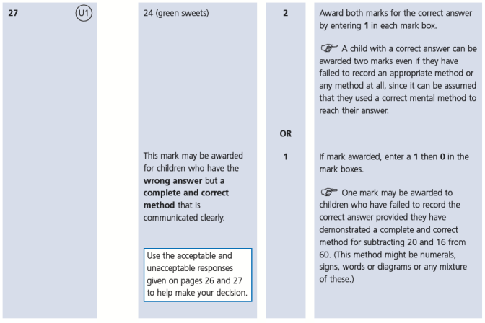
KS1 – 2004 Paper 1
3.
KS1 – 2005 Paper 1
4.
a. 27
b. 5
KS1 – 2005 Paper 2
5.
4

6.
144

KS1 – 2007 Paper 2
7.
KS1 – 2009 Paper 1
8.
KS1 – 2009 Paper 2
9.
10.
11.
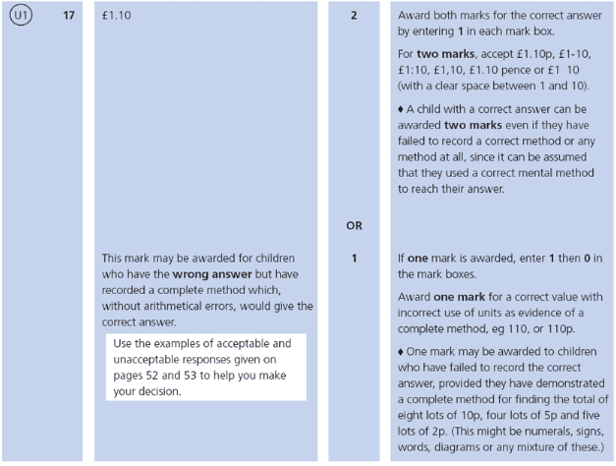
KS1 – 2016 Paper - Reasoning
12.
13.
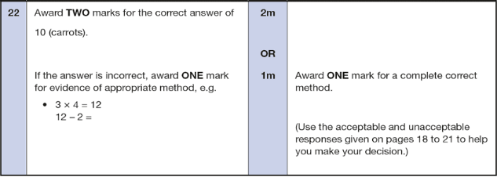
KS1 – 2016 Paper – Reasoning (Second)
14.
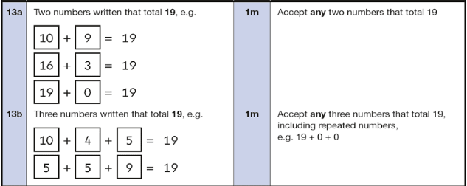
KS1 – 2017 Paper – Reasoning
15.
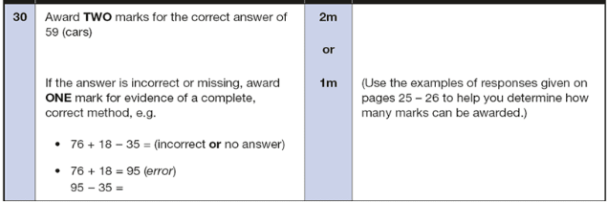
KS1 – 2018 Paper – Reasoning
16.
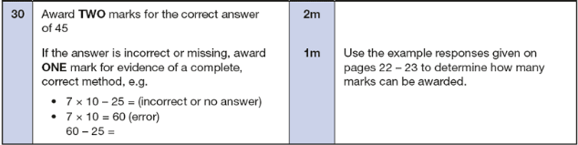
KS1 – 2022 Paper – Reasoning
17.
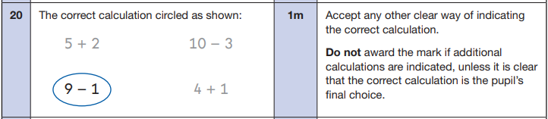
18.
